# «Правила работы в интернете»

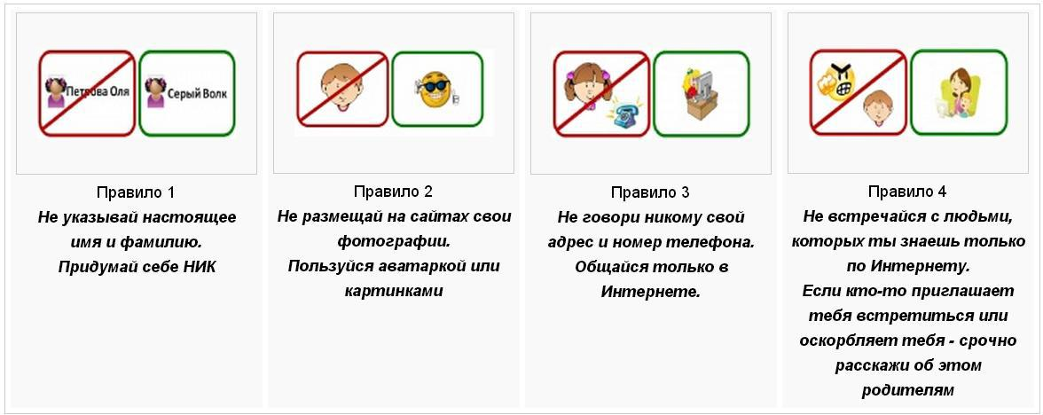

**Ребус-кроссворд**

|  |  |  |  |  |  |  |  |  |  |  |  |  |  |  |  |  |  |  |  |  |  |  |  |  |  |
| --- | --- | --- | --- | --- | --- | --- | --- | --- | --- | --- | --- | --- | --- | --- | --- | --- | --- | --- | --- | --- | --- | --- | --- | --- | --- |
|  |  |  |  |  |  |  |  |  |  |  |  |  |  | **12** |  |  |  |  |  |  |  |  |  |  |  |
|  |  |  |  |  |  |  |  |  |  |  |  |  | **13** |  |  |  |  |  |  |  |  |  |  |  |  |
|  |  |  |  |  | **19** |  |  |  |  | **10** |  |  |  |  |  |  |  |  |  |  |  |  |  | **20** |  |
|  |  |  |  | **14** |  |  |  |  |  |  |  |  |  |  |  | **9** |  |  | **17** |  |  |  |  |  |  |
|  |  |  |  |  |  |  |  |  |  |  |  | **7** |  |  |  |  |  | **18** |  |  |  |  |  |  |  |
|  |  |  |  |  |  |  | **8** |  |  |  |  |  |  |  |  |  |  |  |  |  |  |  |  |  |  |
|  |  |  |  |  |  |  |  |  |  |  |  |  |  |  |  |  |  |  |  |  |  |  |  |  |  |
|  |  |  |  |  |  |  |  |  |  |  |  |  |  |  |  |  |  |  |  |  |  |  |  |  |  |
|  |  |  |  |  |  |  |  |  |  |  |  |  |  |  |  |  |  |  |  |  |  |  |  |  |  |
|  |  |  |  |  |  |  |  |  |  |  |  |  |  |  | **15** |  |  |  |  |  |  |  |  |  |  |
|  |  |  | **16** |  |  |  |  |  | **4** |  |  |  |  |  |  |  |  |  |  |  |  |  |  |  |  |
|  |  |  |  |  |  |  | **6** |  |  |  |  |  |  |  |  |  |  |  |  |  |  |  |  |  |  |
|  | **11** |  |  |  |  |  |  |  |  |  |  |  |  |  |  |  |  |  |  |  |  |  |  |  |  |
| **5** |  |  |  |  |  |  |  |  |  |  |  |  |  |  |  |  |  |  |  |  |  |  |  |  |  |
|  |  |  |  |  |  |  |  |  |  |  | **2** |  |  |  |  |  |  |  |  |  |  |  |  |  |  |
|  |  |  |  |  | **1** |  |  |  |  |  |  |  |  |  |  |  |  |  |  |  |  |  |  |  |  |
|  |  |  |  |  |  |  |  |  |  |  |  |  |  |  |  |  |  |  |  |  |  |  |  |  |  |
|  |  |  |  |  |  |  |  |  |  |  |  |  |  |  |  |  |  |  |  |  |  |  |  |  |  |
|  |  |  |  |  |  |  |  |  |  |  |  |  |  |  |  |  |  |  |  |  |  |  |  |  |  |
|  |  |  |  |  |  |  |  |  |  | **3** |  |  |  |  |  |  |  |  |  |  |  |  |  |  |  |

# По горизонтали

1. 

3.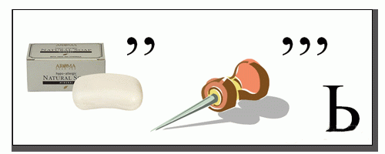

5.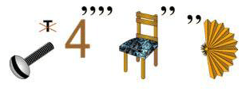

6.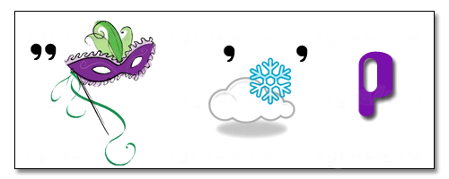

8.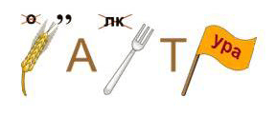

13.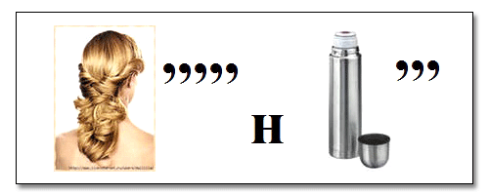

14.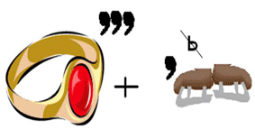

15.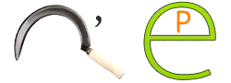

18.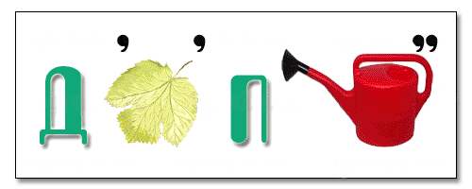

# По вертикали

2.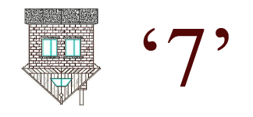

4.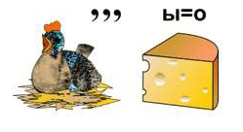

7.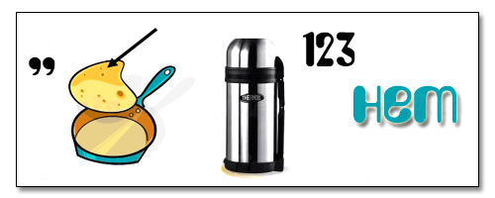

9.

10.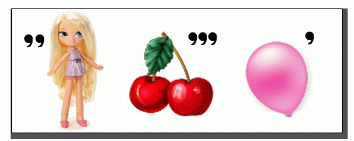

11.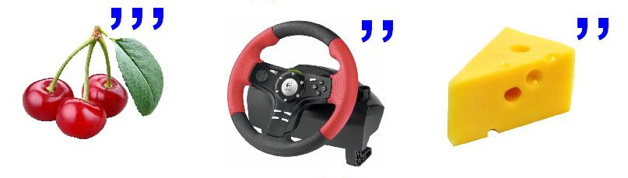

12.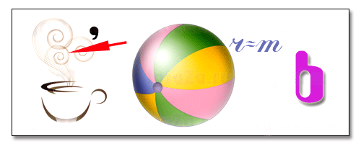

16.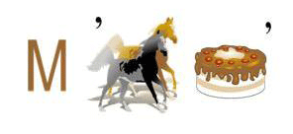

17.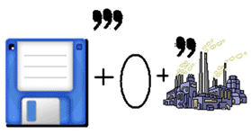

19.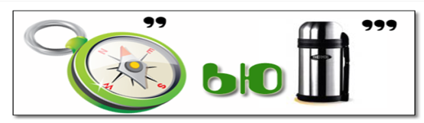

20.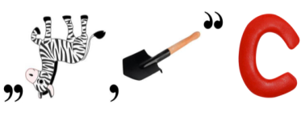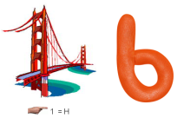

**Сетка с ответами**

|  |  |  |  |  |  |  |  |  |  |  |  |  |  |  |  |  |  |  |  |  |  |  |  |  |  |
| --- | --- | --- | --- | --- | --- | --- | --- | --- | --- | --- | --- | --- | --- | --- | --- | --- | --- | --- | --- | --- | --- | --- | --- | --- | --- |
|  |  |  |  |  |  |  |  |  |  |  |  |  |  | **12** |  |  |  |  |  |  |  |  |  |  |  |
|  |  |  |  |  |  |  |  |  |  |  |  |  | **13** | п | р | и | н | т | е | р |  |  |  |  |  |
|  |  |  |  |  | **19** |  |  |  |  | **10** |  |  |  | а |  |  |  |  |  |  |  |  |  | **20** |  |
|  |  |  |  | **14** | к | о | л | о | н | к | и |  |  | м |  | **9** |  |  | **17** |  |  |  |  | б |  |
|  |  |  |  |  | о |  |  |  |  | л |  | **7** |  | я |  | п |  | **18** | д | и | с | п | л | е | й |
|  |  |  |  |  | м |  | **8** | к | л | а | в | и | а | т | у | р | а |  | и |  |  |  |  | з |  |
|  |  |  |  |  | п |  |  |  |  | в |  | н |  | ь |  | о |  |  | с |  |  |  |  | о |  |
|  |  |  |  |  | ь |  |  |  |  | и |  | т |  |  |  | ц |  |  | к |  |  |  |  | п |  |
|  |  |  |  |  | ю |  |  |  |  | ш |  | е |  |  |  | е |  |  | о |  |  |  |  | а |  |
|  |  |  |  |  | т |  |  |  |  | а |  | р |  |  | **15** | с | е | р | в | е | р |  |  | с |  |
|  |  |  | **16** |  | е |  |  |  | **4** |  |  | н |  |  |  | с |  |  | о |  |  |  |  | н |  |
|  |  |  | м |  | р |  | **6** | с | к | а | н | е | р |  |  | о |  |  | д |  |  |  |  | о |  |
|  | **11** |  | о |  |  |  |  |  | у |  |  | т |  |  |  | р |  |  |  |  |  |  |  | с |  |
| **5** | в | и | н | ч | е | с | т | е | р |  |  |  |  |  |  |  |  |  |  |  |  |  |  | т |  |
|  | и |  | и |  |  |  |  |  | с |  | **2** |  |  |  |  |  |  |  |  |  |  |  |  | ь |  |
|  | р |  | т |  | **1** | и | н | ф | о | р | м | а | т | и | к | а |  |  |  |  |  |  |  |  |  |
|  | у |  | о |  |  |  |  |  | р |  | о |  |  |  |  |  |  |  |  |  |  |  |  |  |  |
|  | с |  | р |  |  |  |  |  |  |  | д |  |  |  |  |  |  |  |  |  |  |  |  |  |  |
|  |  |  |  |  |  |  |  |  |  |  | е |  |  |  |  |  |  |  |  |  |  |  |  |  |  |
|  |  |  |  |  |  |  |  |  |  | **3** | м | ы | ш | ь |  |  |  |  |  |  |  |  |  |  |  |